First step: Open your terminal.
NOTE: You will need sudo access to do this.
Second step: Write “sudo killall -USR1 systemd-resolved” then press enter.
Third step: Write “sudo journalctl -u systemd-resolved > ~/cache.txt” then press enter.
Fourth step: write “nano ~/cache.txt” then press enter.

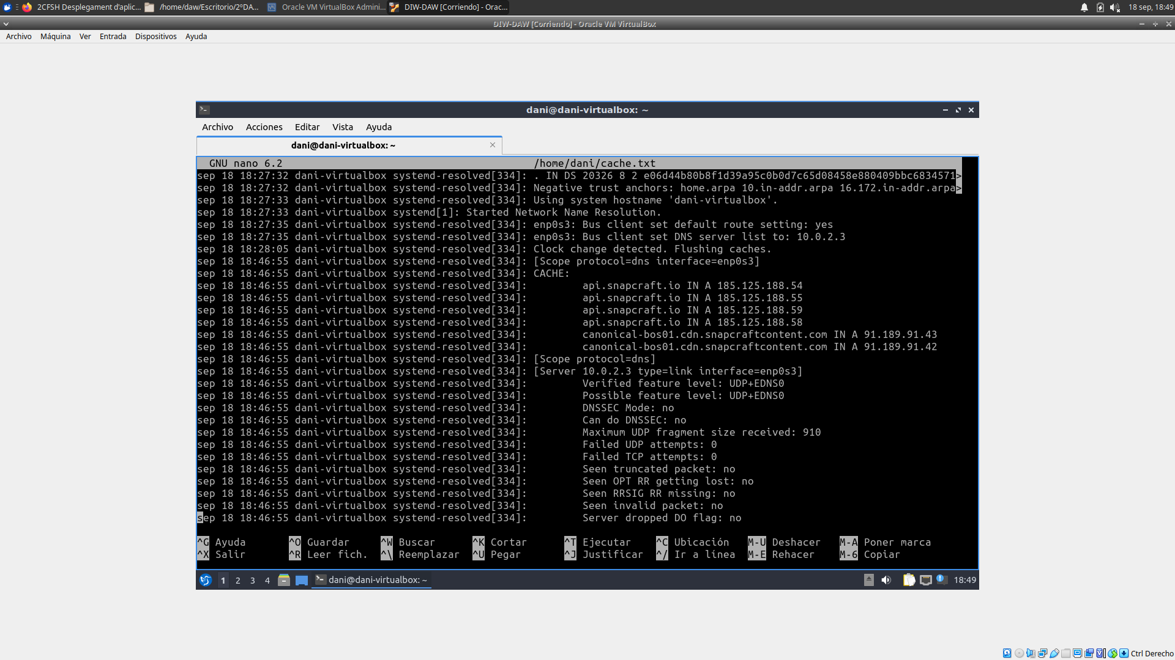
Then, you should be seeing the same thing as in the attached screenshot. And that’s it, that is your DNS cache.

